https://leetcode.com/problems/contains-duplicate/ -- use map
https://leetcode.com/problems/missing-number/description/ -- Do sum of numbers
https://leetcode.com/problems/find-all-numbers-disappeared-in-an-array -- negation of index inplace for O(1) space
https://leetcode.com/problems/two-sum/ - sorted array use two pointer, unsorted array use hash map for the second number and fill the map as we iterate for the first number

https://leetcode.com/problems/how-many-numbers-are-smaller-than-the-current-number/description/
Map needs to be used due to possibility of duplicates.
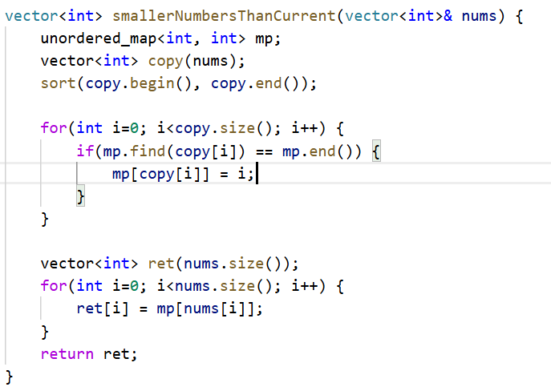

https://leetcode.com/problems/minimum-time-visiting-all-points/

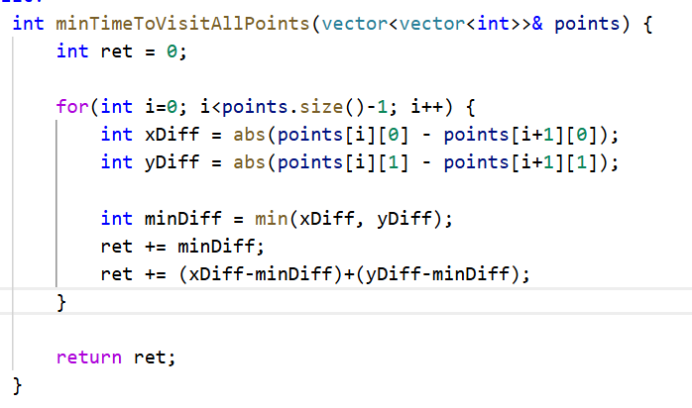
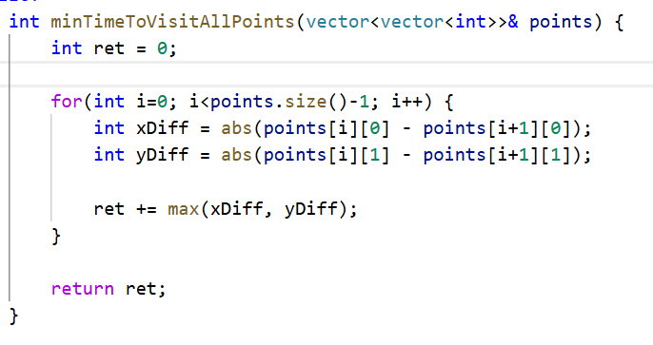

https://leetcode.com/problems/spiral-matrix/

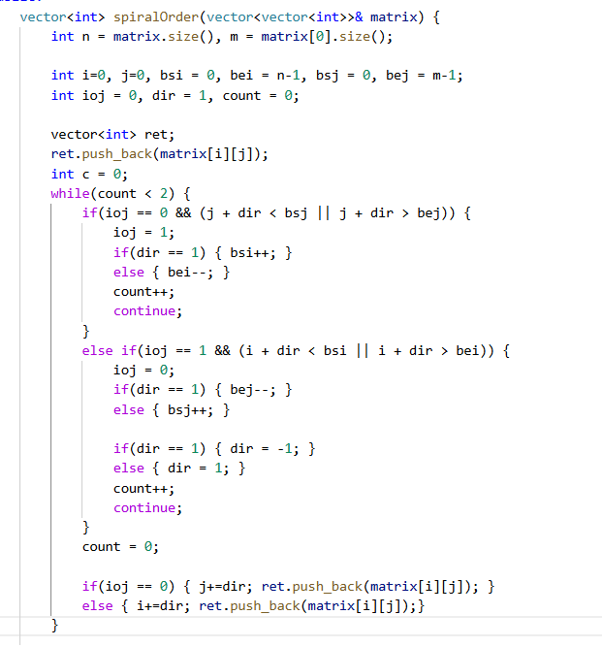

This is much more efficient than below solution but below solution is easier to code.
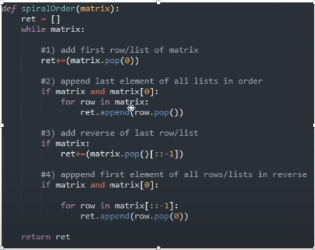

https://leetcode.com/problems/number-of-islands/
– DFS on the islands

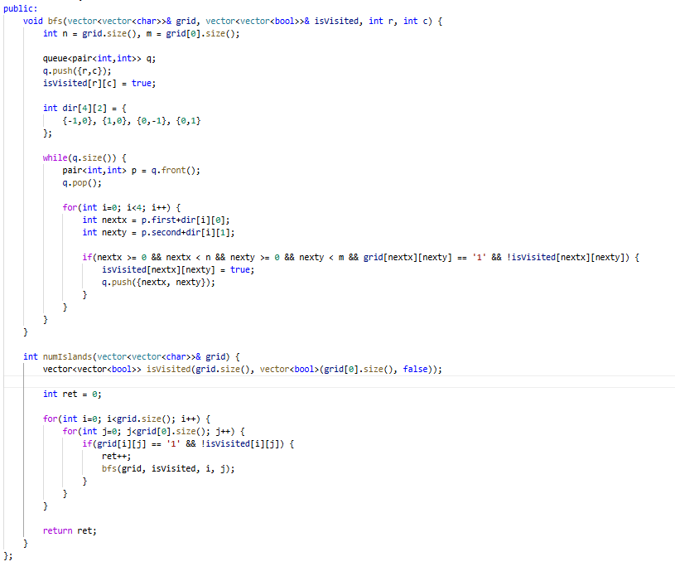

https://leetcode.com/problems/best-time-to-buy-and-sell-stock/
– Initial though was one pointer for left and use a stack to get maximum element on the right and pop out the element from stack as we go along
– Below solution avoid and additional space.

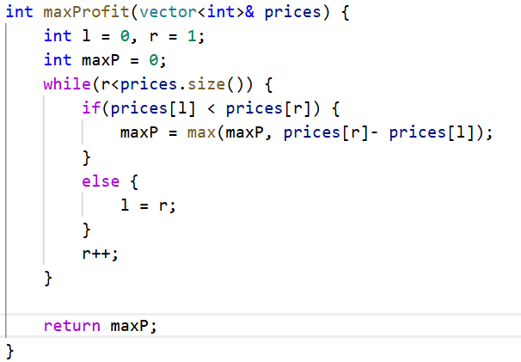

https://leetcode.com/problems/squares-of-a-sorted-array/

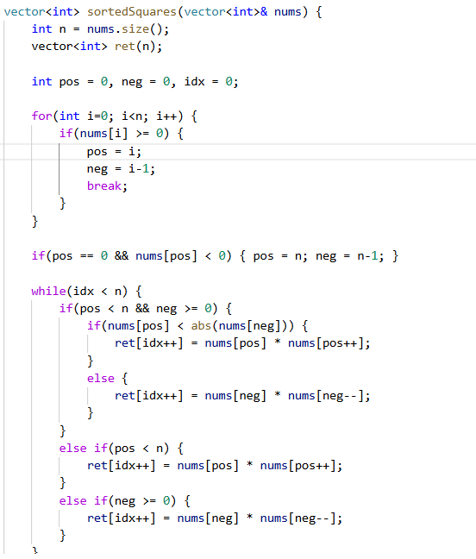
Better solution below. Think of starting from bigger numbers from the end instead of starting numbers from the middle.
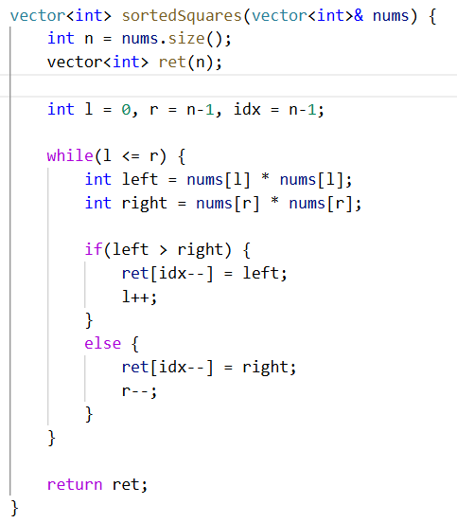

https://leetcode.com/problems/3sum

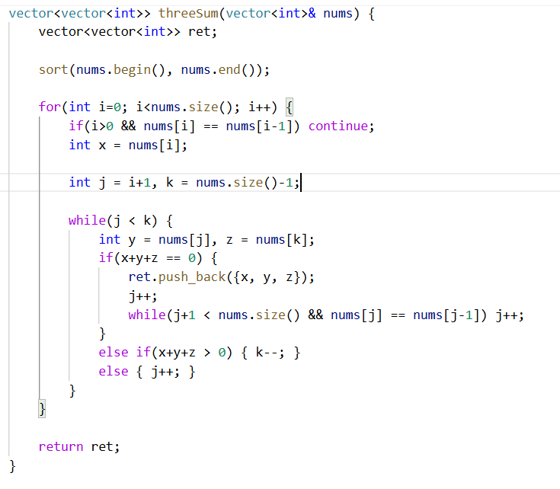
Sorting is required to make sure we don’t add duplicate triplets. Otherwise problem can also be done with hashmap for two sum after fixing x.
https://leetcode.com/problems/longest-mountain-in-array/

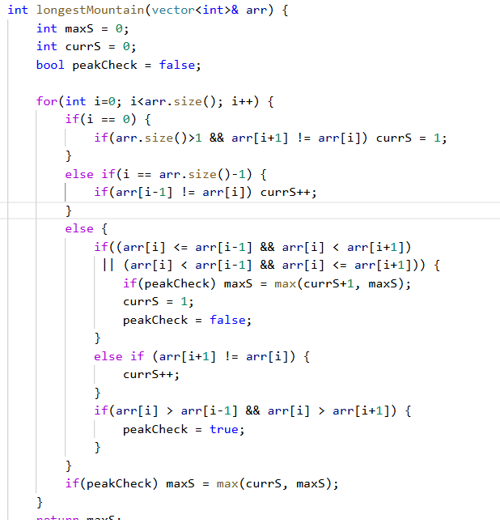

https://leetcode.com/problems/contains-duplicate-ii
- Siliding window of size K with map

https://leetcode.com/problems/minimum-absolute-difference/
- Sort the array
- Find minimum difference between consecutive elements
- Find all consecutive elements with this difference all to result array

https://leetcode.com/problems/minimum-size-subarray-sum/
- Moving window for sum of the subarray

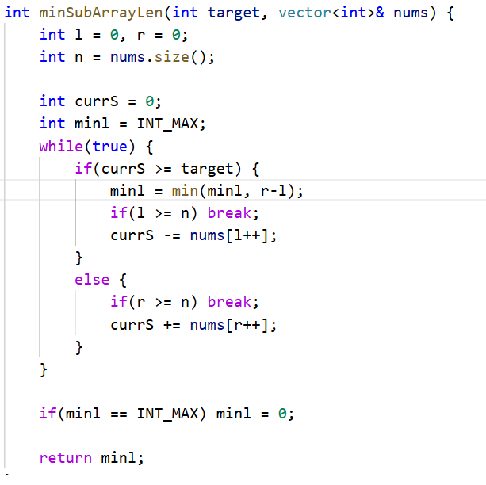

https://leetcode.com/problems/single-number
- XOR all the number and return it.

https://leetcode.com/problems/coin-change/

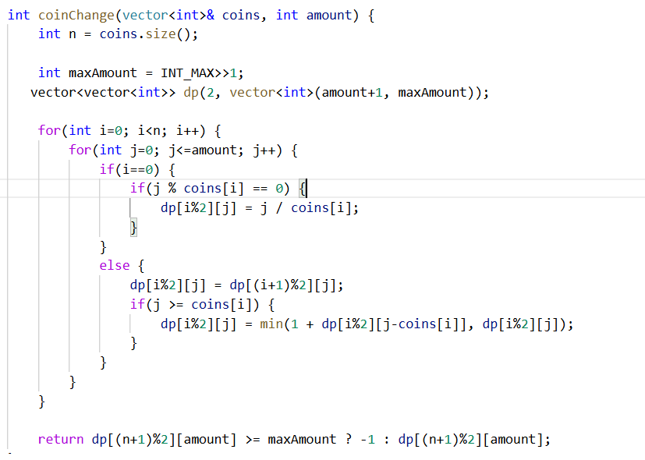

https://leetcode.com/problems/climbing-stairs
- Fibonacci sequence

https://leetcode.com/problems/counting-bits

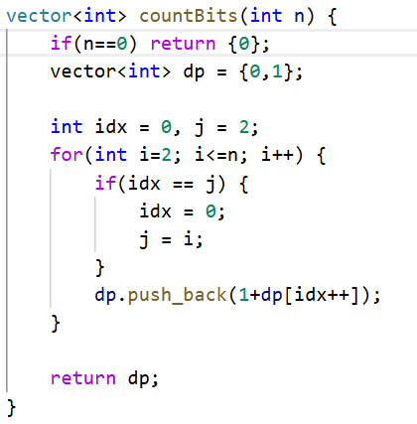

https://leetcode.com/problems/combinations/description/

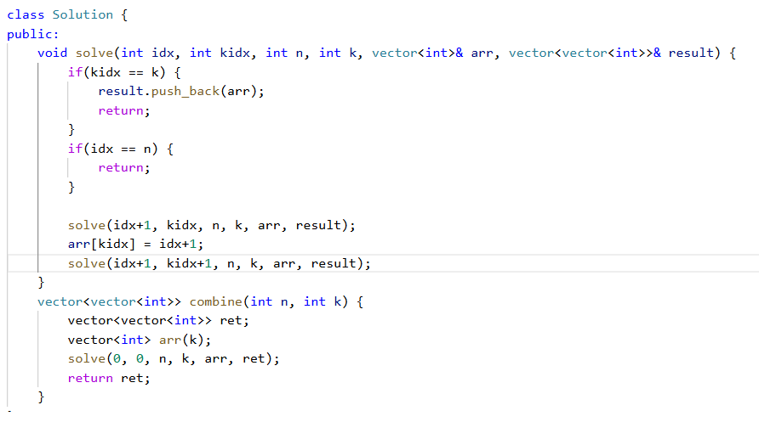

https://leetcode.com/problems/permutations/description/

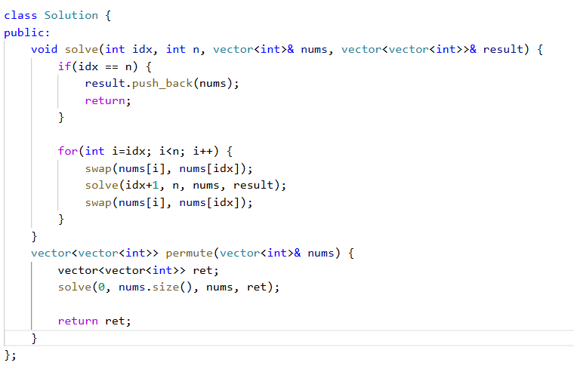

https://leetcode.com/problems/reverse-linked-list-ii/

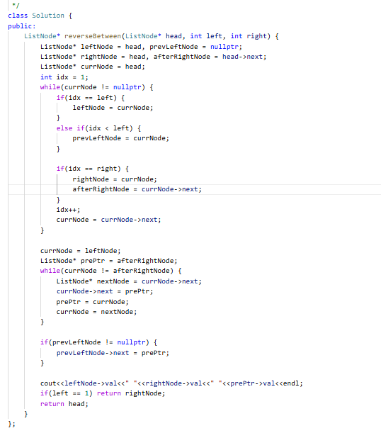

https://leetcode.com/problems/palindrome-linked-list/description/

- Find half point, reverse linked list from there then compare them

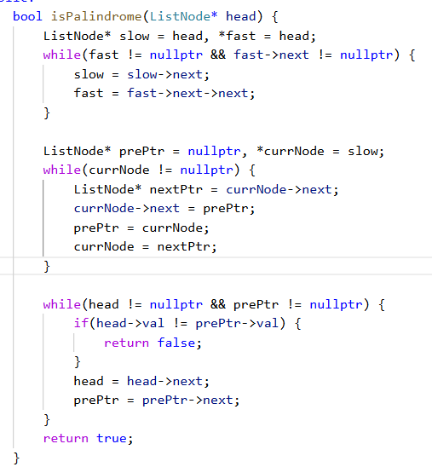

https://leetcode.com/problems/merge-two-sorted-lists/

- Simple loop like merge sort
- Dummy node is better and reduces code
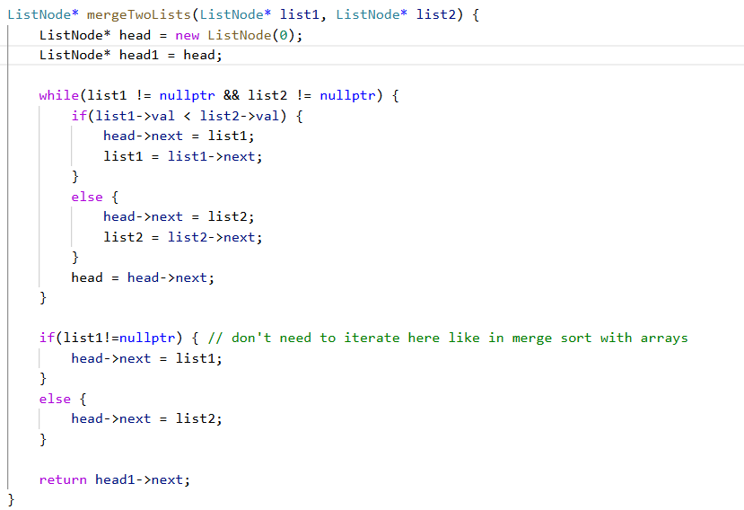

https://leetcode.com/problems/min-stack/

- if(val < minele) {
- st.push(2*val - minele);
- minele = val;
- }

- val - minele < 0
- Val + val +minele < val
- 2*val + minele < 0

https://www.geeksforgeeks.org/design-a-stack-that-supports-getmin-in-o1-time-and-o1-extra-space/

- Double storage method

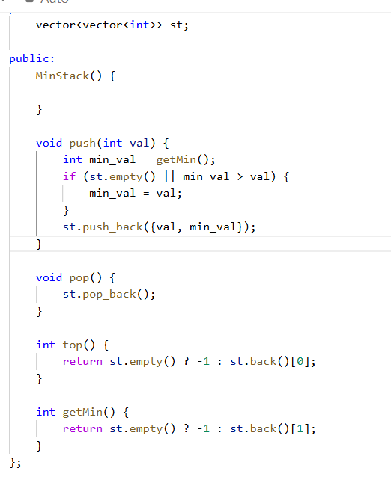

https://leetcode.com/problems/evaluate-reverse-polish-notation/

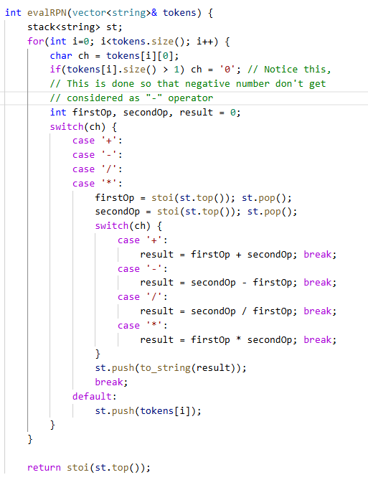

https://www.geeksforgeeks.org/problems/sort-a-stack

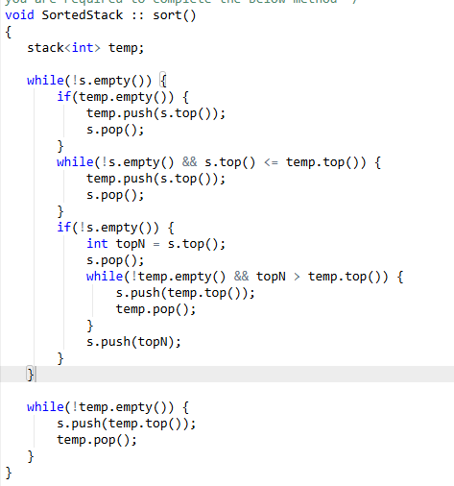

https://leetcode.com/problems/implement-stack-using-queues

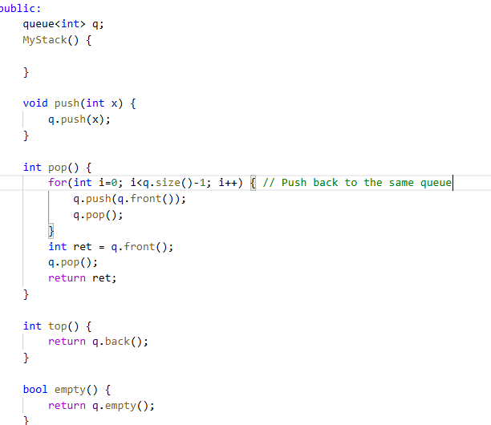

https://leetcode.com/problems/time-needed-to-buy-tickets/description/

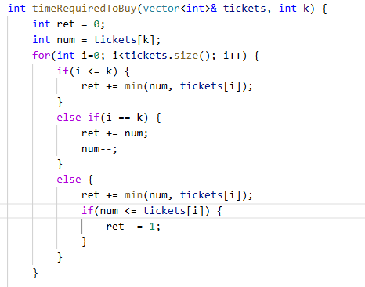

https://leetcode.com/problems/unique-substrings-in-wraparound-string/description/

https://leetcode.com/problems/moving-stones-until-consecutive-ii/

Sol - https://leetcode.com/problems/moving-stones-until-consecutive-ii/solutions/289357/c-with-picture/

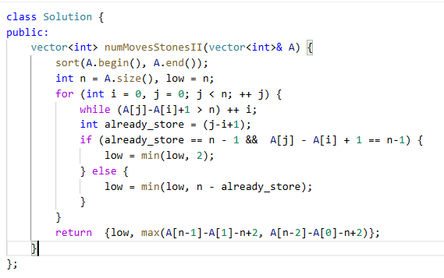

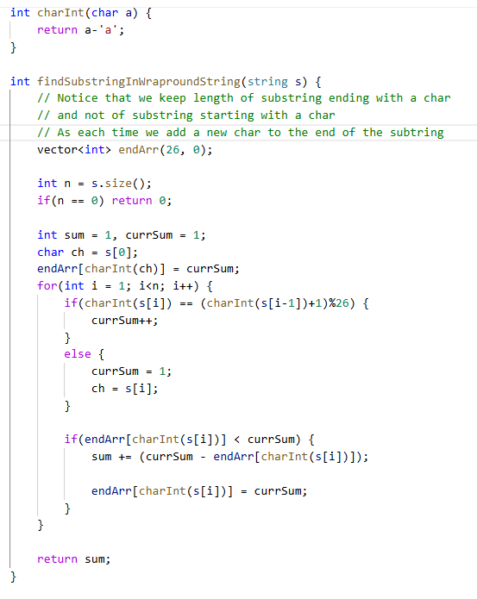

https://leetcode.com/problems/maximize-win-from-two-segments/description/

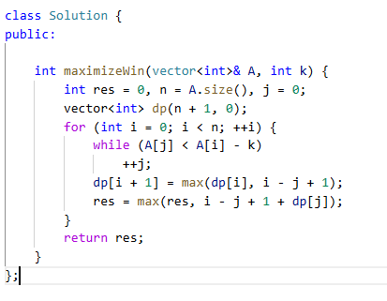

https://leetcode.com/problems/minimum-size-subarray-in-infinite-array/

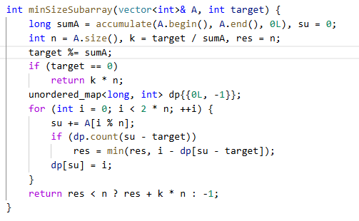

https://leetcode.com/discuss/post/3171859/journey-to-a-faang-company-amazon-sde2-l-avdi/

https://leetcode.com/problems/minimum-cost-tree-from-leaf-values

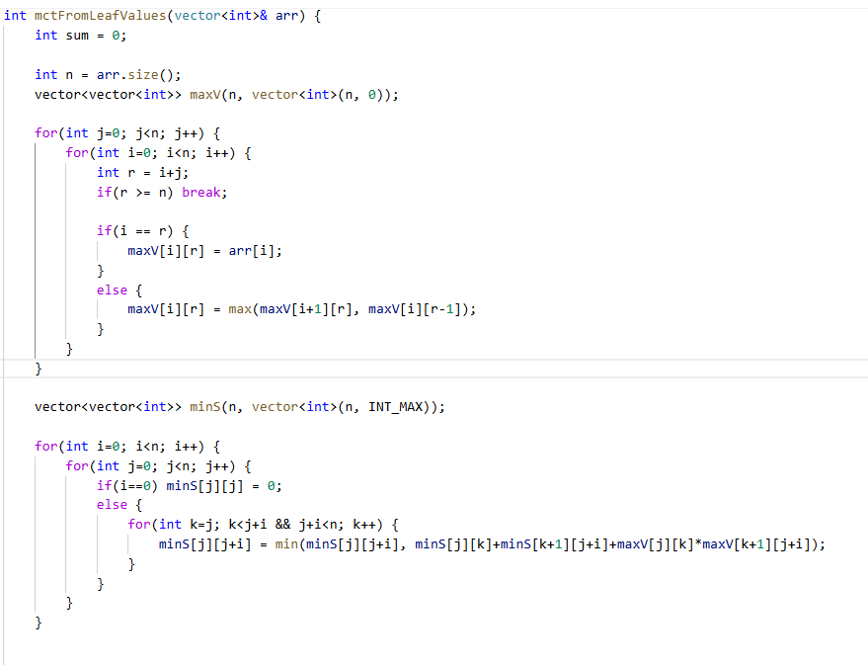
Similar to matrix chain multiplication

https://leetcode.com/problems/maximum-number-of-visible-points/

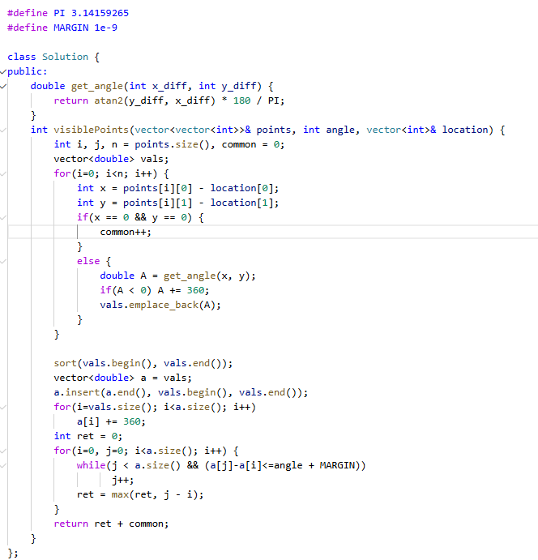

https://leetcode.com/problems/shortest-bridge

BFS with a priority queue

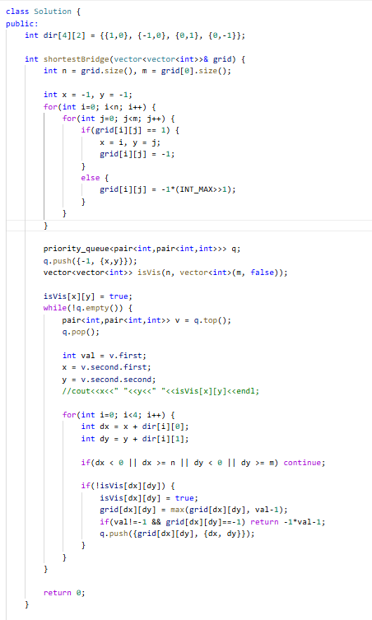

https://leetcode.com/problems/find-median-from-data-stream

Min Heap + Max Heap

https://leetcode.com/problems/lowest-common-ancestor-of-a-binary-search-tree

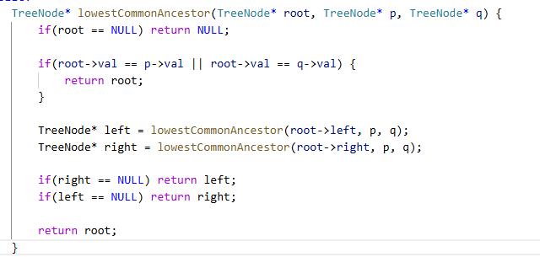

https://leetcode.com/problems/lru-cache

Doubly linked list + map

https://leetcode.com/problems/burst-balloons

- Think of bursting the selected balloon last to make the other two sections on the left and right independent
https://leetcode.com/problems/burst-balloons/solutions/892552/for-those-who-are-not-able-to-understand-any-solution-with-diagram/

https://leetcode.com/problems/valid-palindrome/

- Iswalnum to find alphanumeric or not
- tolower() to get lower number
- Two pointer for checking palindrome

https://leetcode.com/problems/simplify-path

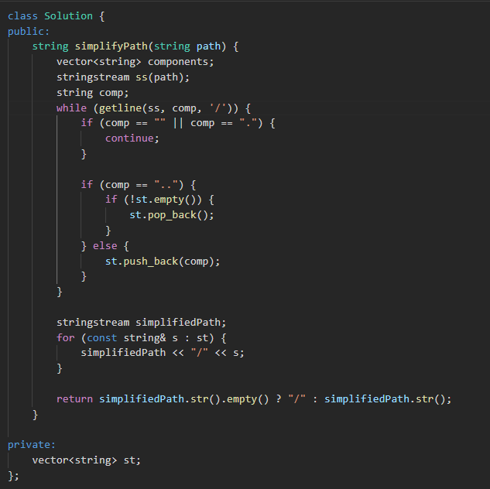

https://leetcode.com/problems/task-scheduler/description/

- Use max priority queue to process the task with most frequency at the given time.
- Process the tasks in cycles.

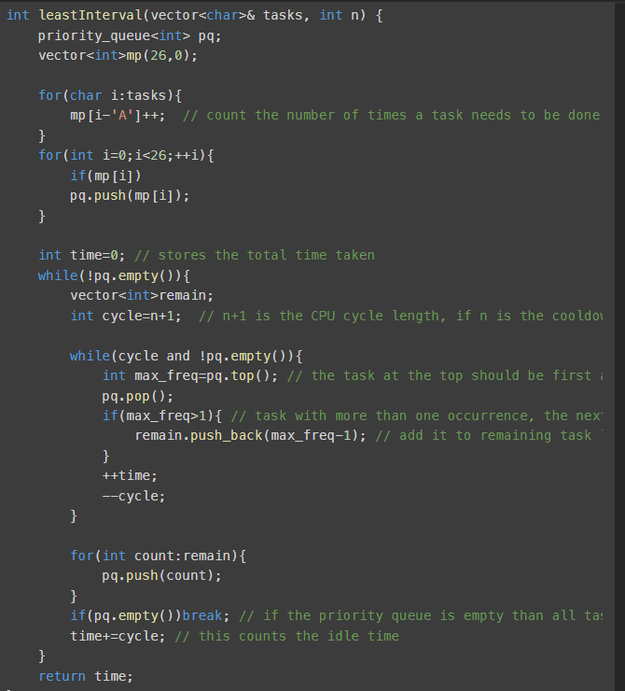

https://leetcode.com/problems/recover-binary-search-tree

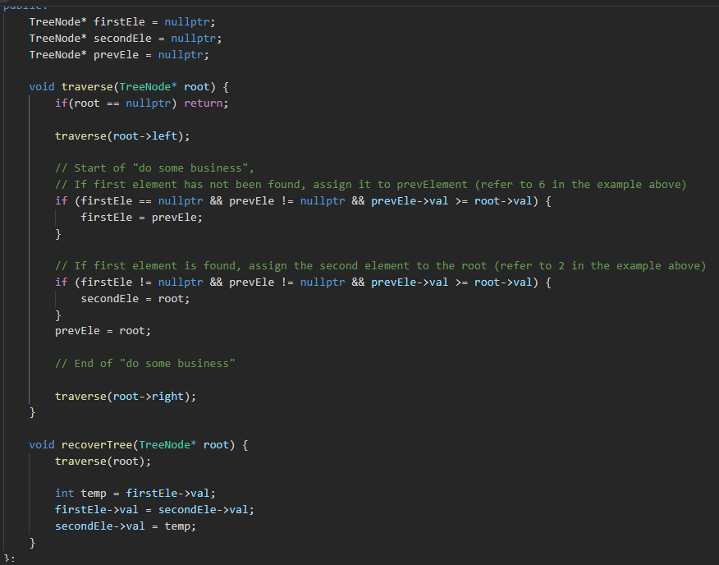

https://leetcode.com/problems/24-game/description/

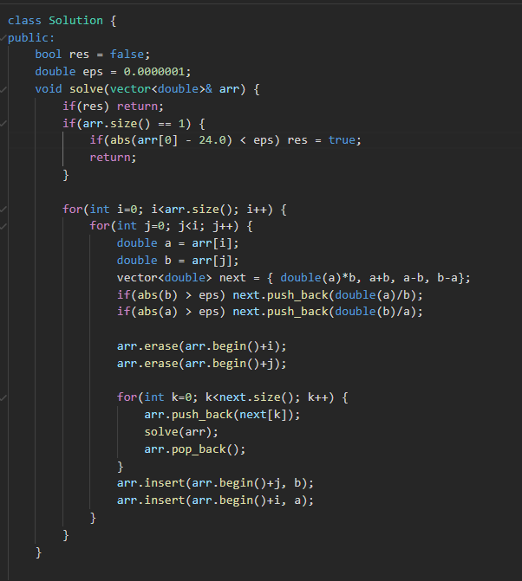

https://leetcode.com/problems/k-th-smallest-prime-fraction/description/

- Min Heap with reducing ranges of the array from 0, n-1 to either 1, n-1 or 0,n-2 and similarly for other smaller ranges

https://leetcode.com/problems/find-the-most-competitive-subsequence/

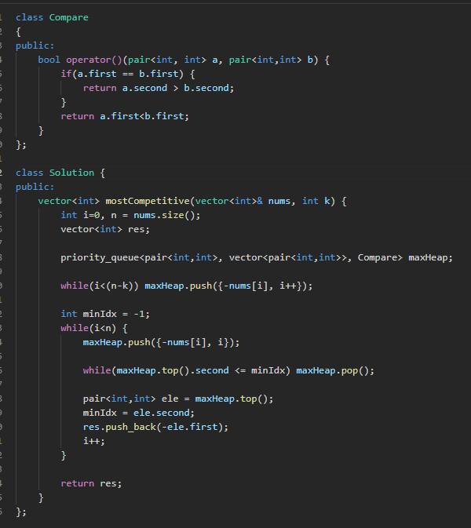

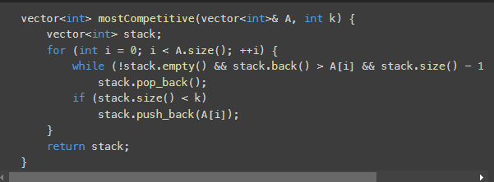

https://www.hackerearth.com/practice/notes/binary-indexed-tree-or-fenwick-tree/

https://leetcode.com/problems/count-of-smaller-numbers-after-self/

https://leetcode.com/problems/word-break/description/

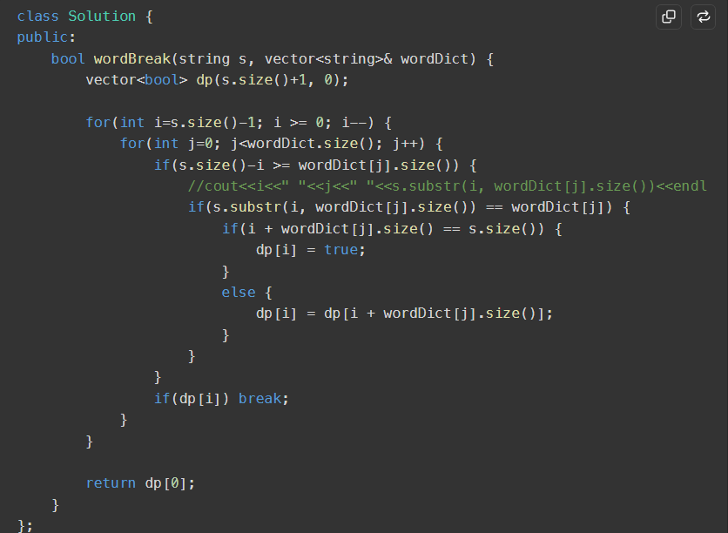

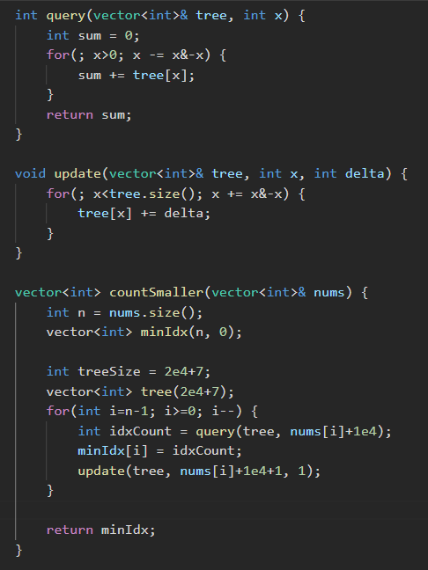

https://leetcode.com/problems/subtree-of-another-tree/

- Hashing of the tree and subtree

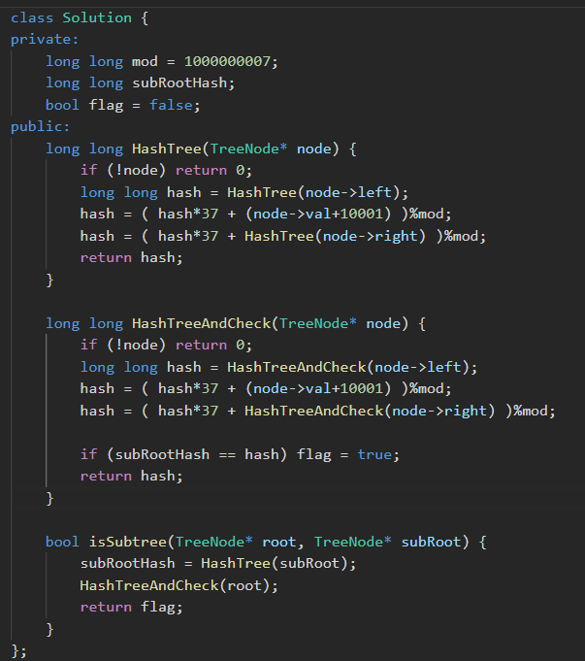

- Searching from preorder and inorder traversals also works but require extra space

https://leetcode.com/problems/jump-game-ii/

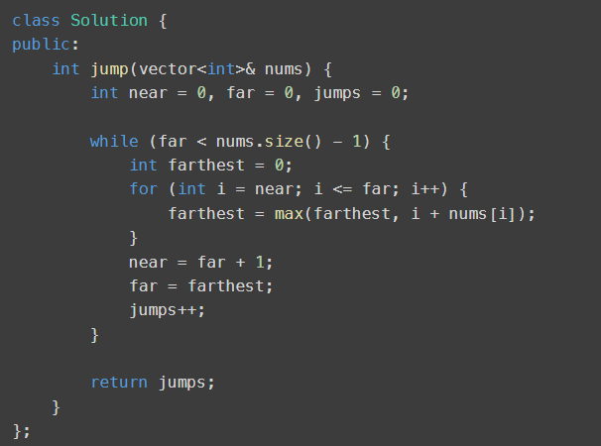

https://leetcode.com/problems/linked-list-cycle-ii/description/

- Fast and slow pointer

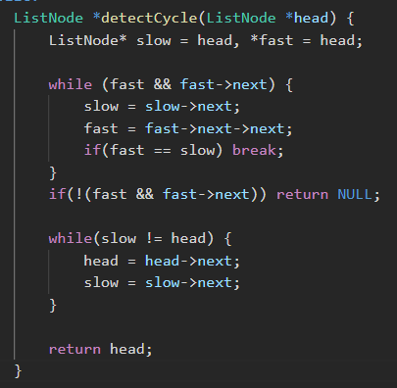

https://leetcode.com/problems/insert-delete-getrandom-o1/

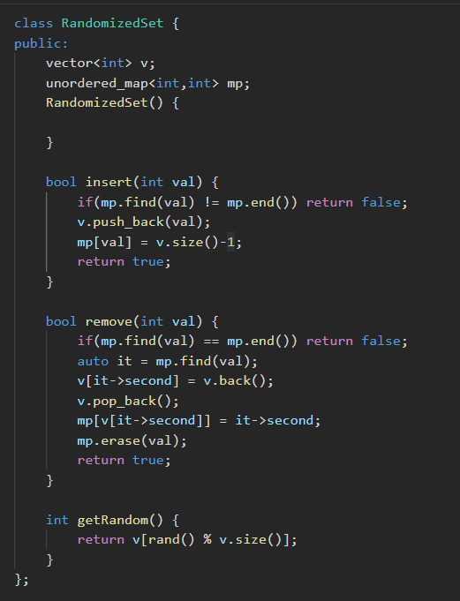

***** Very good program

https://leetcode.com/problems/maximal-rectangle/

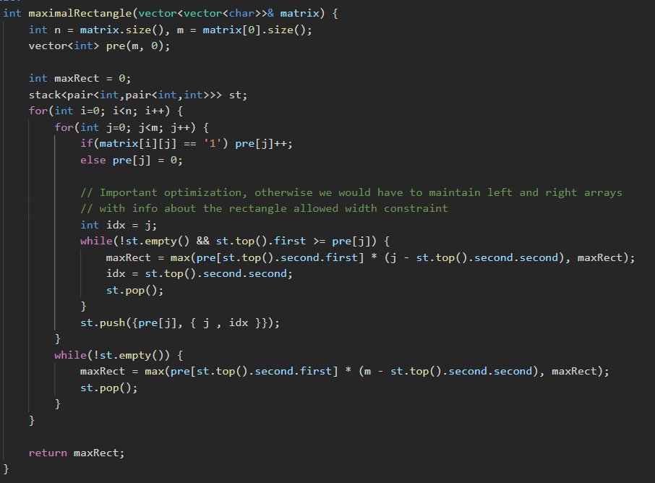

https://leetcode.com/problems/surrounded-regions

//Steps to Solve :
//1. Move over the boundary of board, and find O's
//2. Every time we find an O, perform DFS from it's position
//3. In DFS convert all 'O' to '#' (why?? so that we can differentiate which 'O' can be flipped and which cannot be)
//4. After all DFSs have been performed, board contains three elements,#,O and X
//5. 'O' are left over elements which are not connected to any boundary O, so flip them to 'X'
//6. '#' are elements which cannot be flipped to 'X', so flip them back to 'O'
//7. finally, Upvote the solution😊

https://leetcode.com/problems/the-skyline-problem/description/

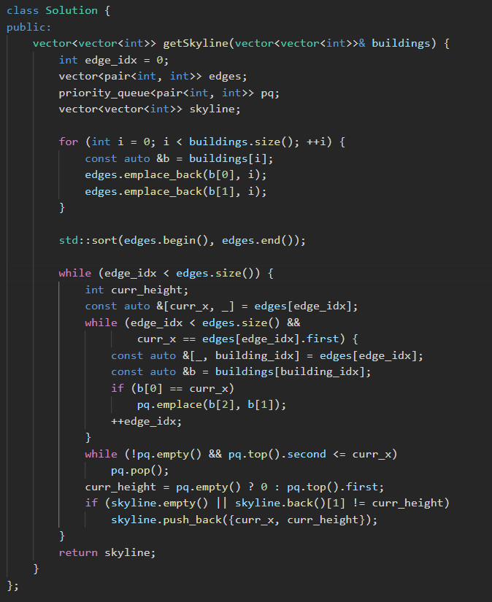
https://leetcode.com/problems/binary-tree-cameras/

Solution - https://leetcode.com/problems/binary-tree-cameras/solutions/211180/java-c-python-greedy-dfs/

https://leetcode.com/problems/verifying-an-alien-dictionary/description/
- https://leetcode.com/problems/verifying-an-alien-dictionary/submissions/1601977736/
- Compare class usage

https://leetcode.com/problems/longest-increasing-path-in-a-matrix/

- https://leetcode.com/problems/longest-increasing-path-in-a-matrix/solutions/6666138/video-solution-2-approaches-dfs-dp-and-topological-sort-complete-intuition-explained-c/

- Initially I did with priority queue but it can also be done with a simple queue and using indegree matrix (topological sort).
- It can also be done with simple dfs and memoization.

https://leetcode.com/problems/integer-break/

- https://leetcode.com/problems/integer-break/solutions/6210269/video-give-me-10-minutes-how-we-think-about-a-solution-no-difficult-mathematics/
- Divide into threes and if remainder is 1, reduce the threes and set remainder to 4

https://leetcode.com/problems/construct-binary-tree-from-preorder-and-postorder-traversal

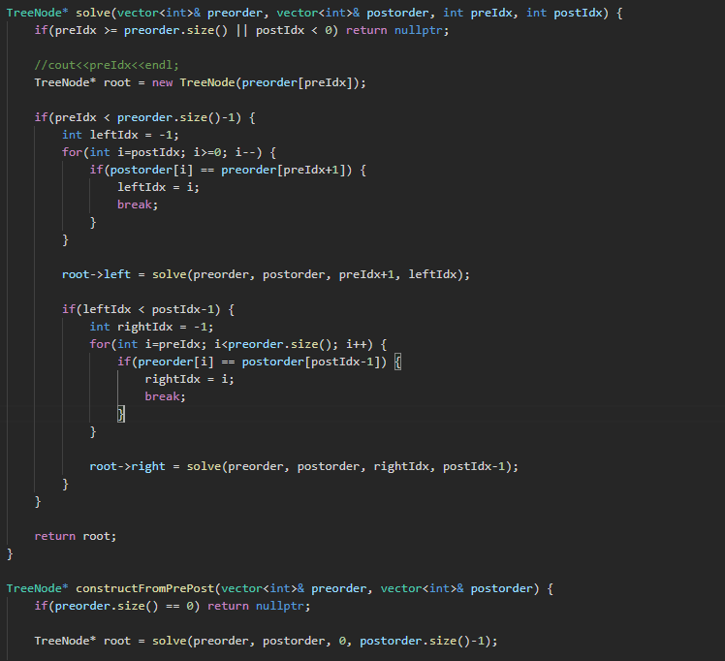

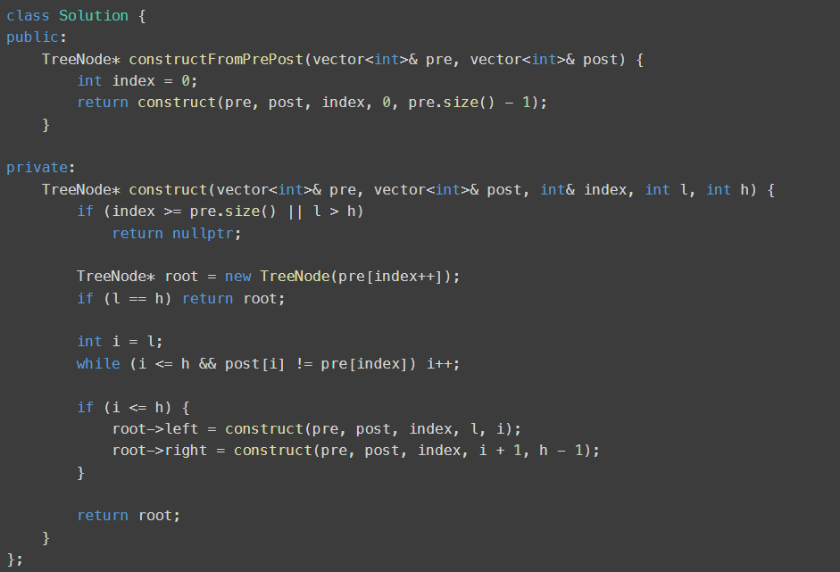

https://leetcode.com/problems/non-overlapping-intervals/

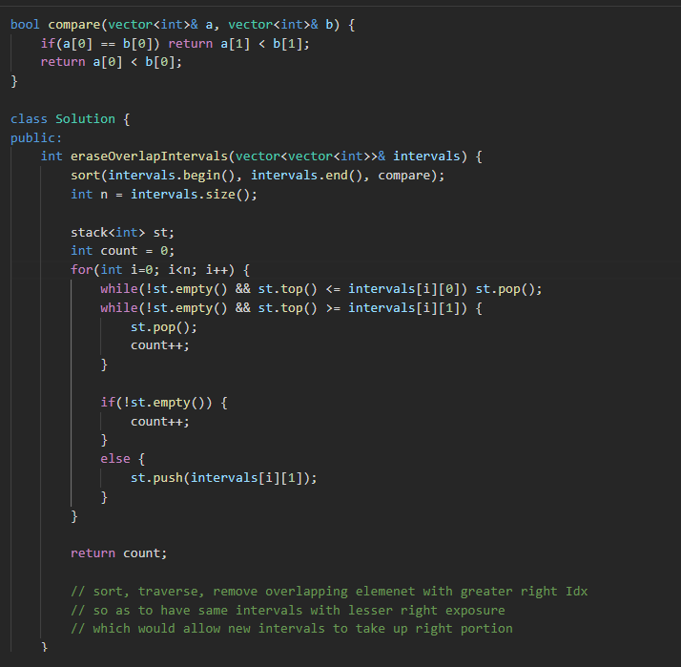

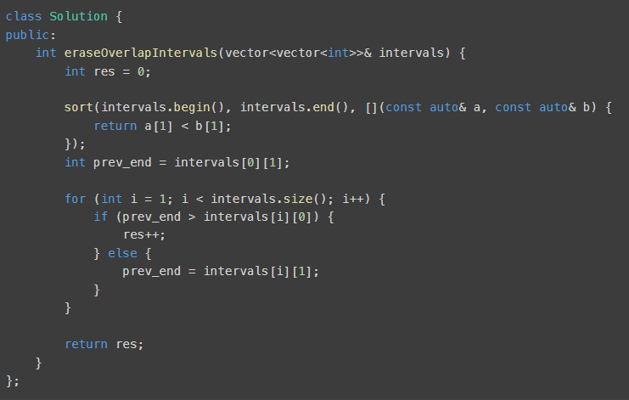

https://leetcode.com/problems/find-the-duplicate-number

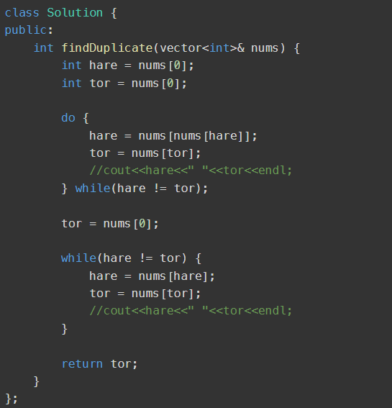

https://leetcode.com/problems/reverse-nodes-in-k-group/
- Double recursion, one recursion (loop) for reversing k nodes and other for dividing the problem in parts

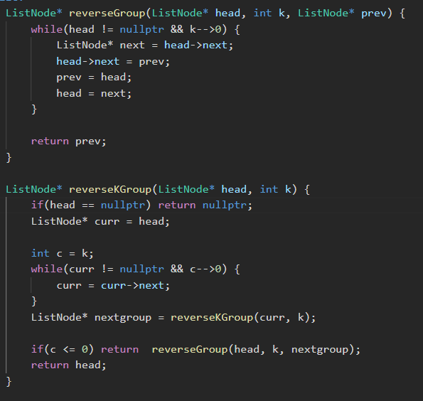

https://leetcode.com/problems/maximum-product-subarray/

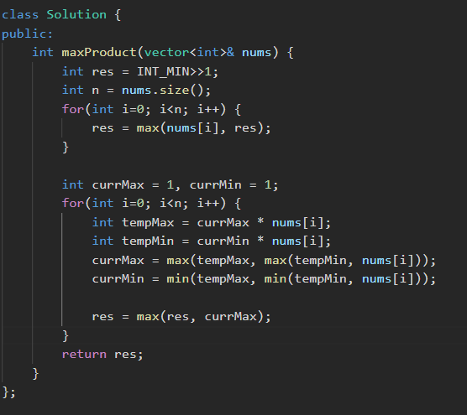

*** Important
https://leetcode.com/problems/verifying-an-alien-dictionary/

- Compare operation with a Compare class
https://leetcode.com/problems/verifying-an-alien-dictionary/submissions/1601977736/

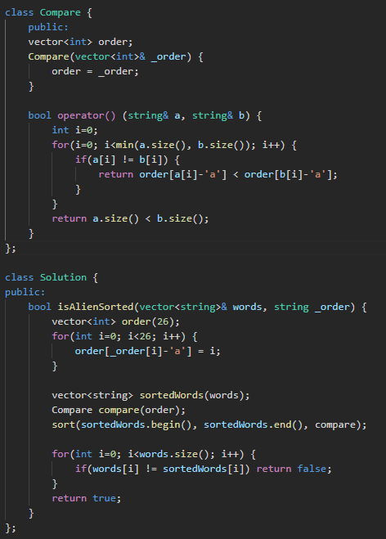

https://leetcode.com/problems/is-graph-bipartite
- Note: BFS cannot be used as the graph may not be fully connected and still be bipartite

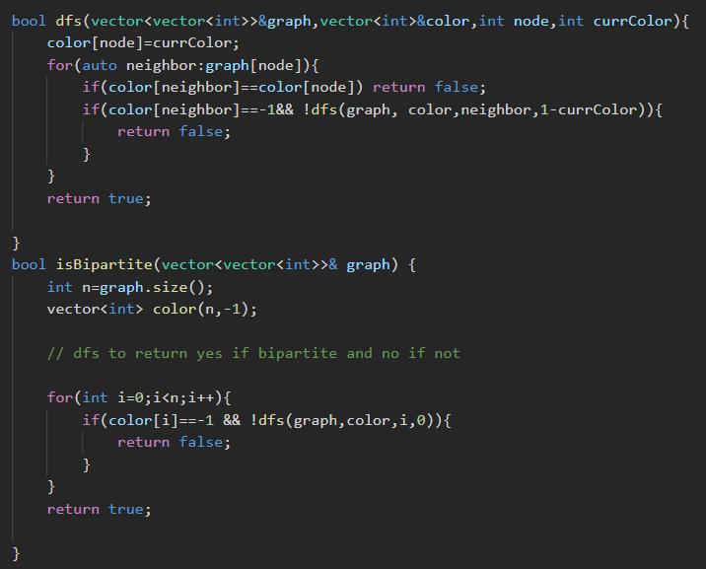

https://leetcode.com/problems/divide-two-integers

https://leetcode.com/problems/divide-two-integers/submissions/1619532311/

*** Good question related to sliding window
https://leetcode.com/problems/substring-with-concatenation-of-all-words/description/

- https://leetcode.com/problems/substring-with-concatenation-of-all-words/submissions/1614922134/

https://leetcode.com/problems/find-the-city-with-the-smallest-number-of-neighbors-at-a-threshold-distance/

– Floyd warshall algorithm to get distance from each node to each node
– dijkstra also works but slower

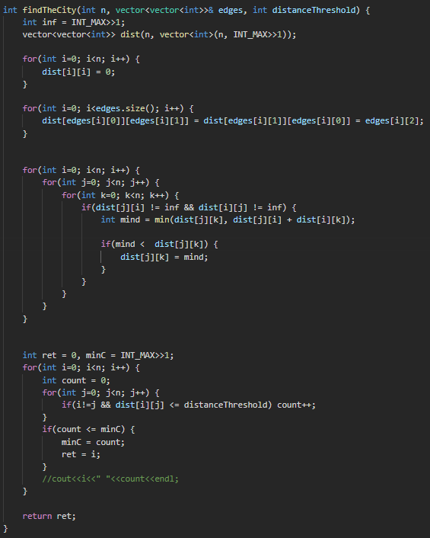

https://leetcode.com/problems/lowest-common-ancestor-of-a-binary-tree/submissions/1622855855/

https://leetcode.com/problems/longest-valid-parentheses

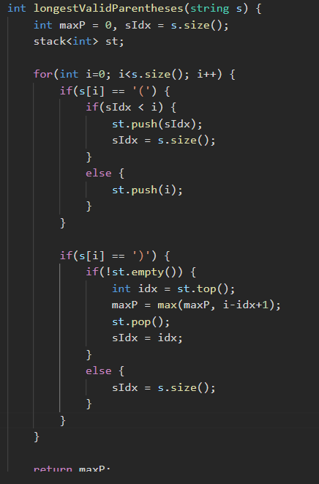

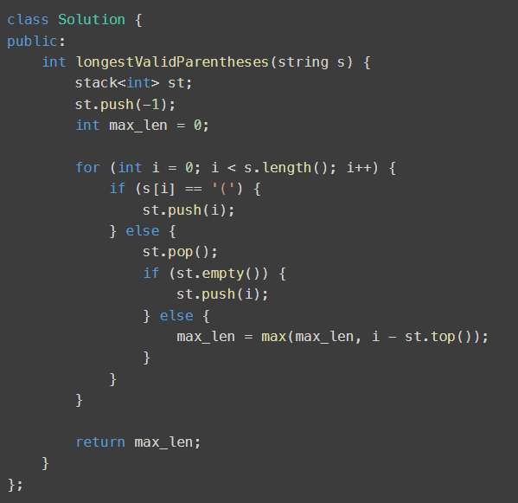

https://leetcode.com/problems/basic-calculator (*** Important)

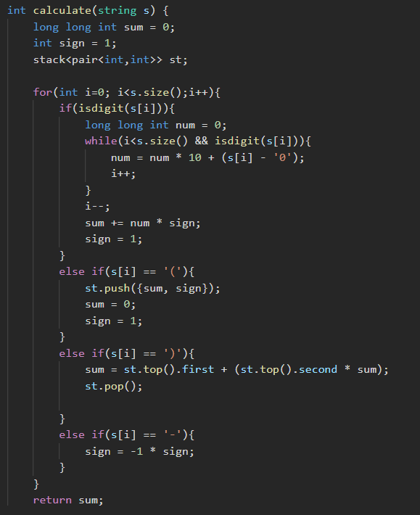

https://leetcode.com/problems/all-oone-data-structure/submissions/1624427246/
- For just log(n) time for each operation, binary set or heap can be used to map count to a key
- For O(1) for each operation we have to use double linked list (too much logic) (maybe revise it a few times)
https://leetcode.com/problems/all-oone-data-structure/solutions/5847164/brute-better-most-demanding-doubly-linked-list-optimal-full-concept-illustration/

https://leetcode.com/problems/next-permutation/submissions/1624624760/

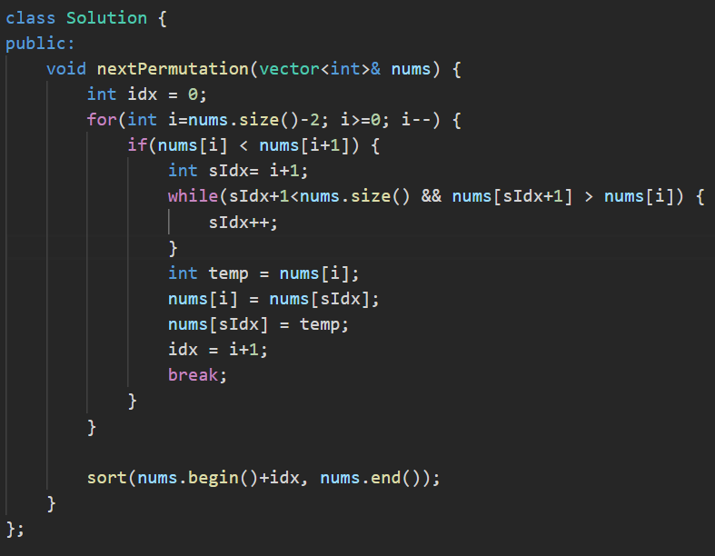

https://leetcode.com/problems/course-schedule-ii/

- BFS solution with maintaining indegrees and only adding to the queue when indegree has become zero. But we need to perform cycle detection separately for each node first before doing BFS.
- Actual cycle detection can be avoided by just checking for result size at the end. If result size is equal to number of courses then no cycle in the graph.
- DFS can also be used with indegrees and doing DFS of child if indegree has become zero.

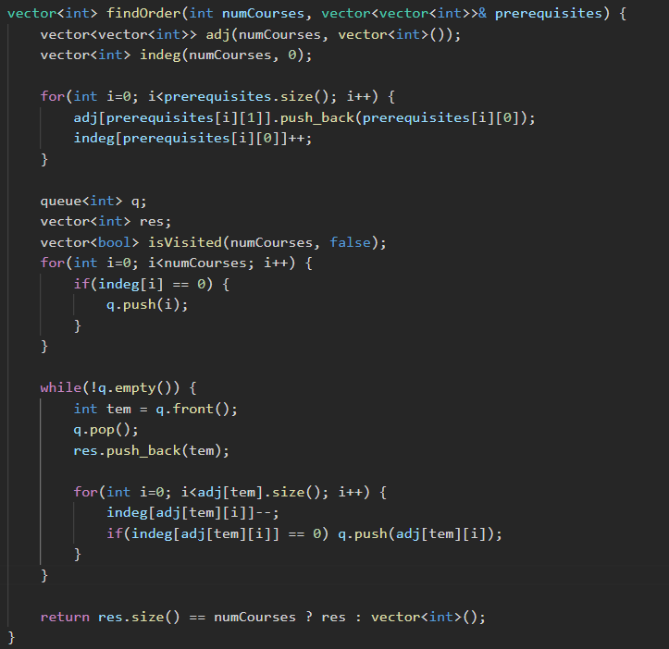

https://leetcode.com/problems/find-all-duplicates-in-an-array/submissions/1625333290/

- If more than twice duplicate then a big number can be added to the numbers each time. And at the end divide by the big number (mod) and check count.

https://leetcode.com/problems/implement-stack-using-queues/submissions/1555821887/

https://leetcode.com/problems/possible-bipartition/
- DFS with coloring

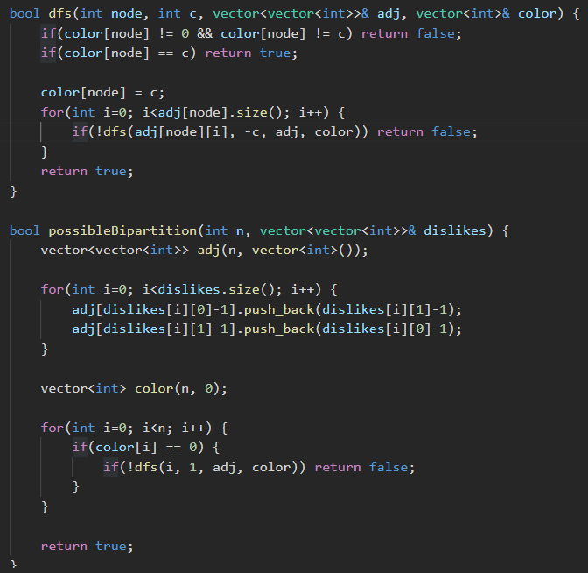

https://leetcode.com/problems/regular-expression-matching/
- https://leetcode.com/problems/regular-expression-matching/submissions/1630028802/

https://leetcode.com/problems/merge-intervals
- Notice sorting need to be done based on startIndex and not endIndex unlike job scheduling problem where sorting needs to be done by endIndex.

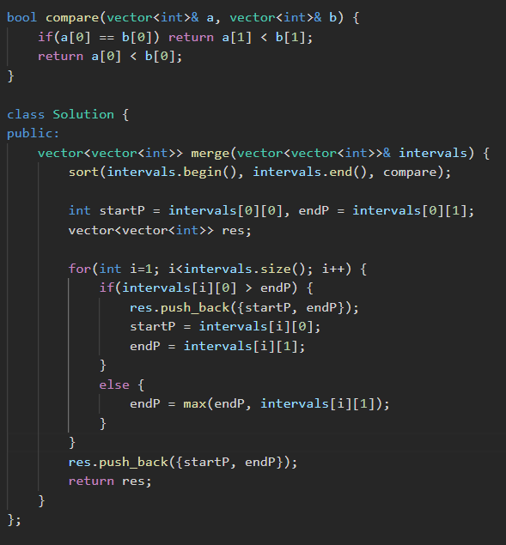

https://leetcode.com/problems/minimum-time-to-make-rope-colorful/
- First attempted with recursive with memoization
- Then converted to DP solution by changing bottom up to top down. Change idx+1 calls in recursion to [i-1] access in DP solution.
- Remove one dimension from DP as only alphabet size array was sufficient.
- Realize only two numbers are important from the last run of the DP.

https://leetcode.com/problems/minimum-time-to-make-rope-colorful/submissions/1630227282/

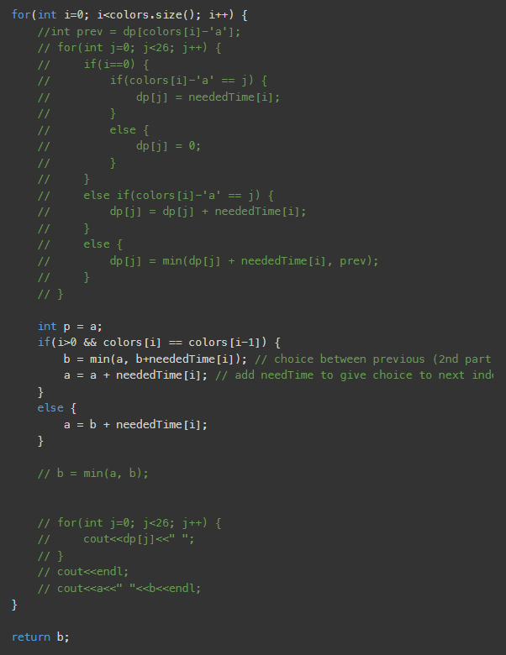
https://leetcode.com/problems/jump-game/submissions/1630722093/

https://leetcode.com/problems/3sum-closest/

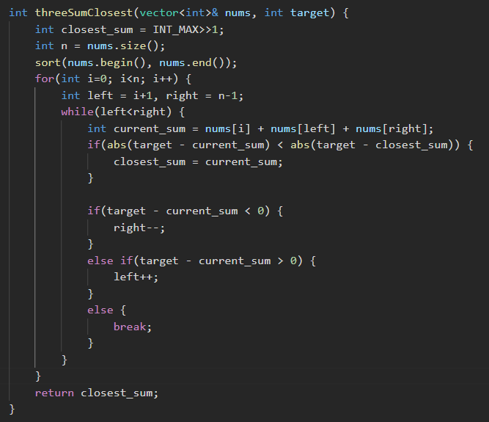

https://leetcode.com/problems/longest-substring-without-repeating-characters

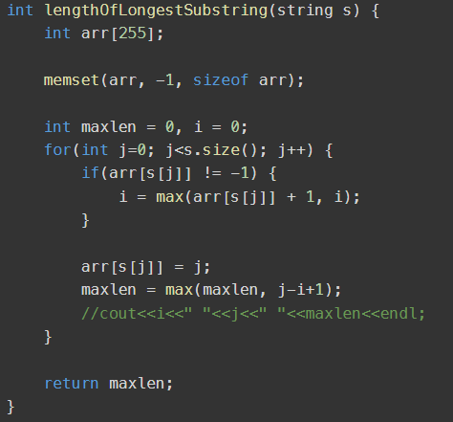

https://leetcode.com/problems/knight-dialer/submissions/1630765728/

https://leetcode.com/problems/3sum/submissions/1544813461/

https://leetcode.com/problems/minimum-remove-to-make-valid-parentheses

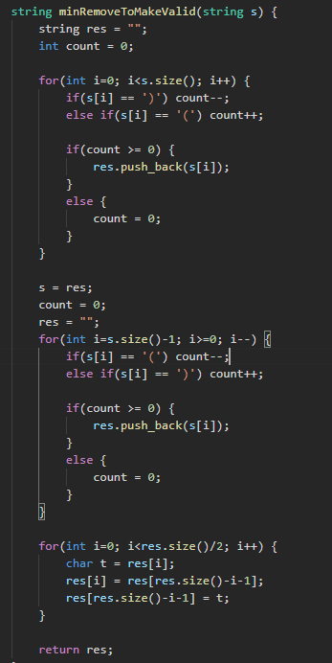

https://leetcode.com/problems/reachable-nodes-in-subdivided-graph/

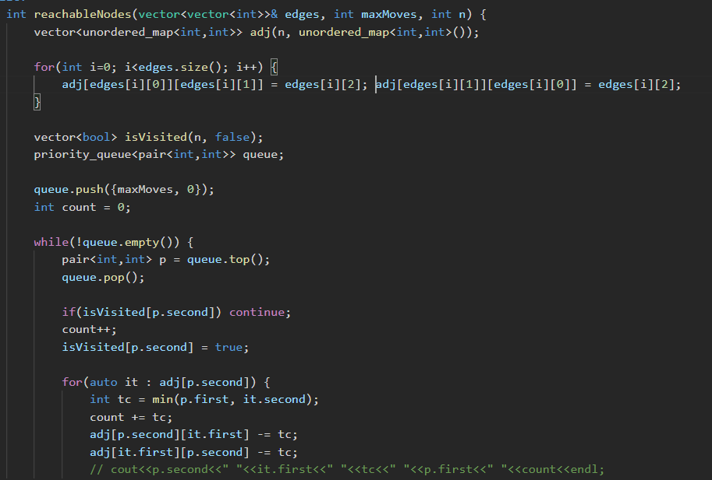
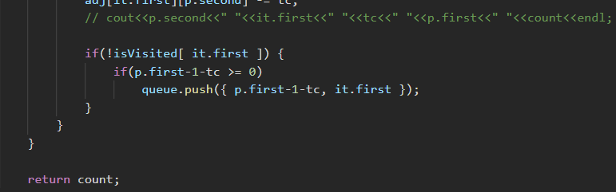

https://leetcode.com/problems/binary-search-tree-iterator/
- Assign right pointer as next node in inorder traversal for all nodes.

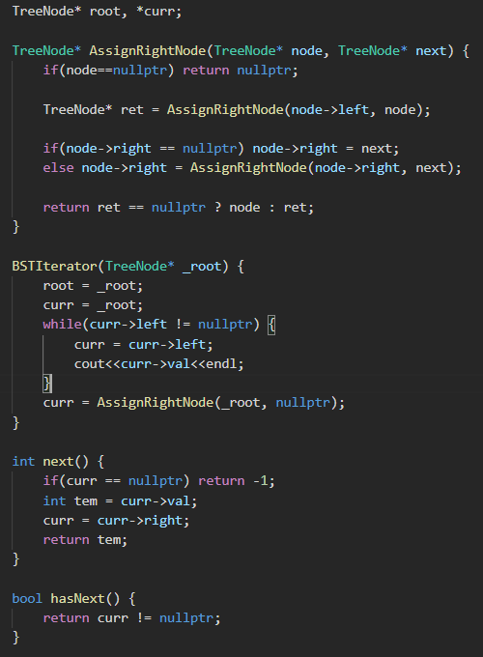

- O(h) space and O(1) amortized time complexity.
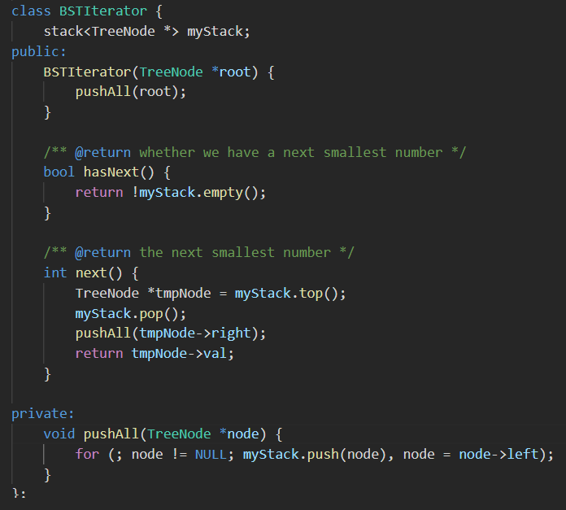

https://leetcode.com/problems/continuous-subarray-sum/description/

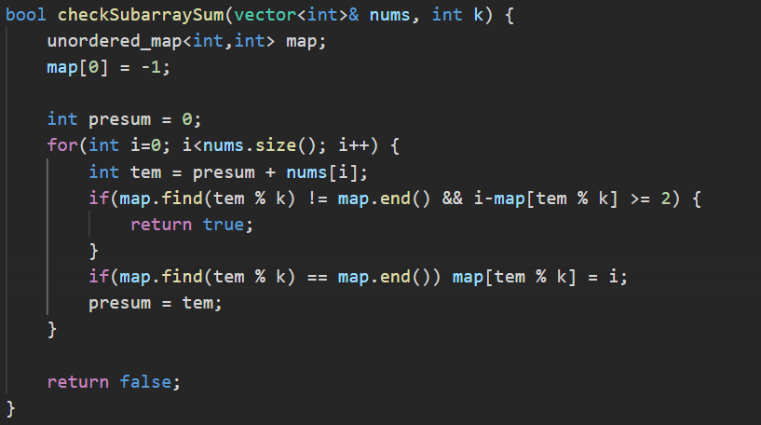

https://leetcode.com/problems/longest-palindromic-substring/

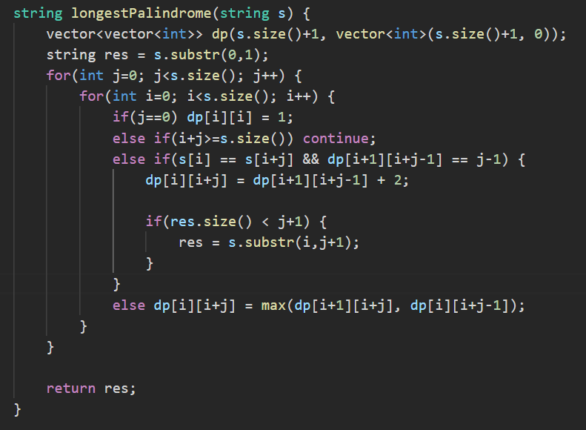

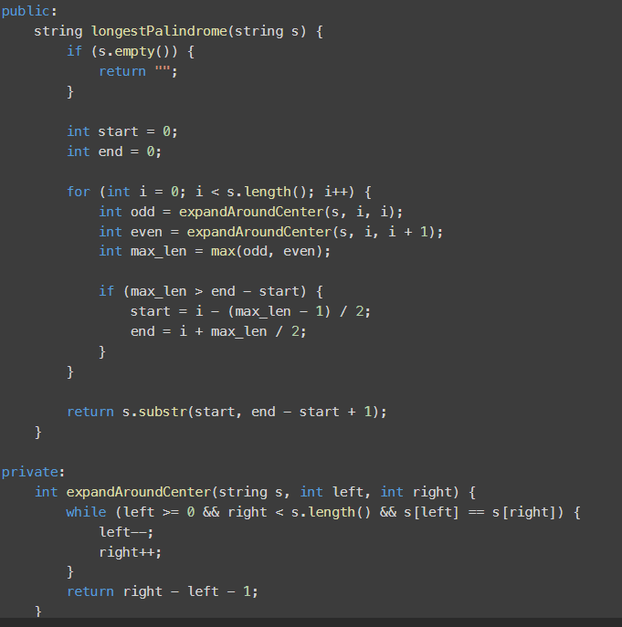

https://leetcode.com/problems/critical-connections-in-a-network
- https://leetcode.com/problems/critical-connections-in-a-network/submissions/1637418031/ - Using a modified version of strongly connected components
- Tarjan’s algorithm - https://leetcode.com/problems/critical-connections-in-a-network/solutions/1174196/js-python-java-c-tarjan-s-algorithm-solution-w-explanation/

https://leetcode.com/problems/squares-of-a-sorted-array/submissions/1543969043/

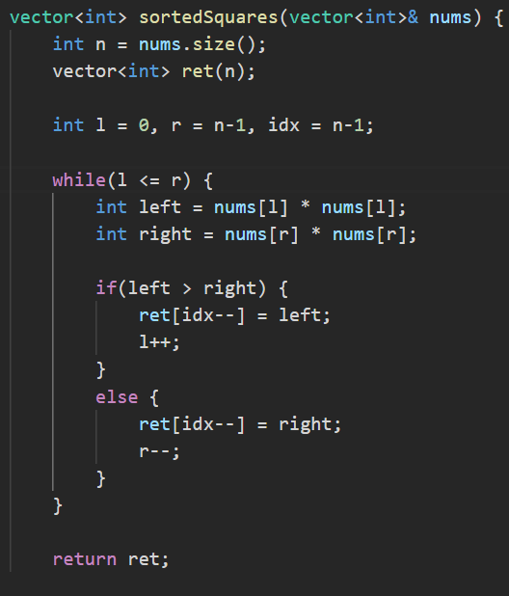

https://leetcode.com/problems/sqrtx/
- Binary search for sqrt of x

https://leetcode.com/problems/maximum-number-of-events-that-can-be-attended/
- Priority queue
- https://leetcode.com/problems/maximum-number-of-events-that-can-be-attended/submissions/1639651057/

https://leetcode.com/problems/median-of-two-sorted-arrays

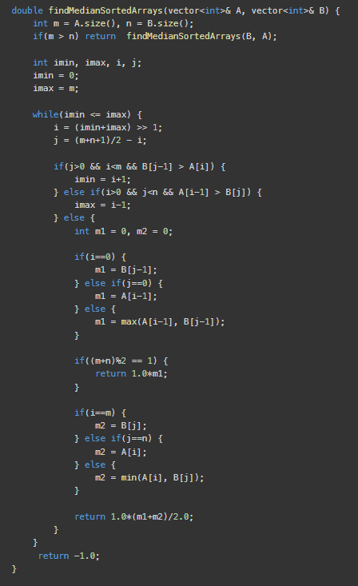
https://leetcode.com/problems/max-sum-of-rectangle-no-larger-than-k/
- Combination of kadane’s algo for rectangle - https://www.youtube.com/watch?v=yCQN096CwWM and max subarray sum till K - https://www.quora.com/Given-an-array-of-integers-A-and-an-integer-k-find-a-subarray-that-contains-the-largest-sum-subject-to-a-constraint-that-the-sum-is-less-than-k

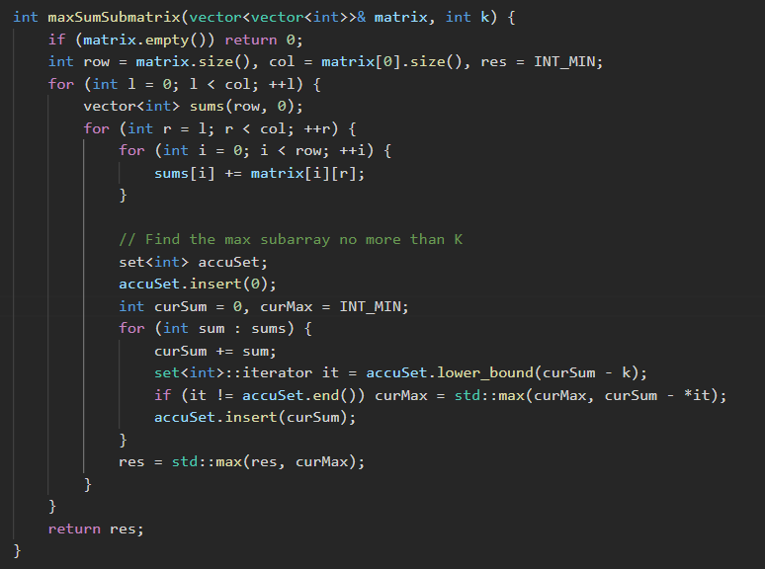

https://leetcode.com/problems/contain-virus
- https://leetcode.com/problems/contain-virus/submissions/1643337566/

https://leetcode.com/problems/integer-to-english-words/
- https://leetcode.com/problems/integer-to-english-words/submissions/1643806149/

https://leetcode.com/problems/minimum-limit-of-balls-in-a-bag

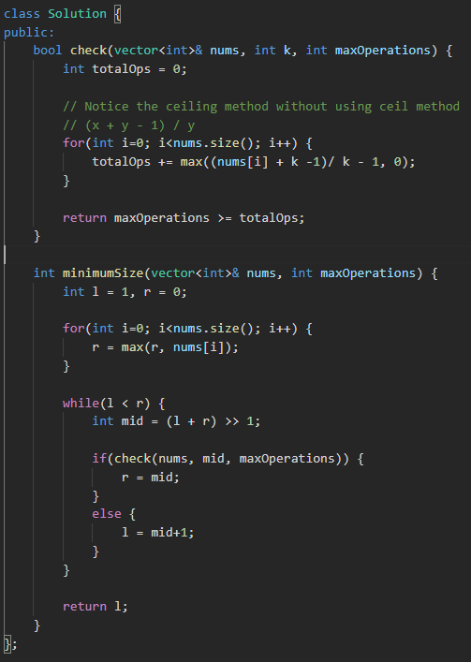

https://leetcode.com/problems/permutations-ii/
- Ensure sub arrays (sub permutations) are sorted as well.

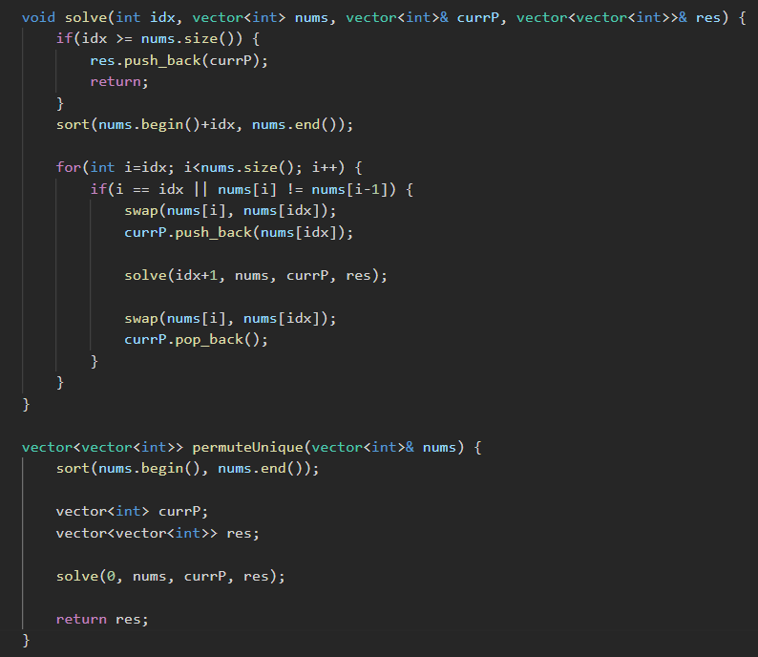

https://leetcode.com/problems/longest-repeating-character-replacement
- https://leetcode.com/problems/longest-repeating-character-replacement/solutions/6146343/animated-video-sliding-window-template-and-visualization/

https://leetcode.com/problems/longest-increasing-subsequence

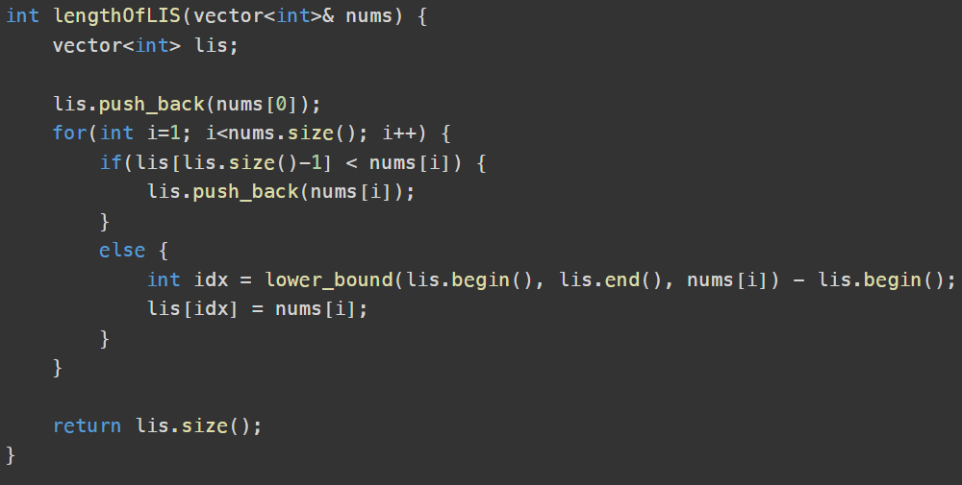

https://leetcode.com/problems/valid-square/
- https://leetcode.com/problems/valid-square/submissions/1647326320/

https://leetcode.com/problems/divisor-game/
- Even number = win, odd number = loose

https://leetcode.com/problems/zigzag-conversion/
- https://leetcode.com/problems/zigzag-conversion/submissions/1647638178/

https://leetcode.com/problems/minimum-moves-to-equal-array-elements
- Subtract all numbers with minimum number
- https://leetcode.com/problems/minimum-moves-to-equal-array-elements/submissions/1663802919/

https://leetcode.com/problems/path-sum-iii/
- Prefix sum with unordered_map to find targetSum
- https://leetcode.com/problems/path-sum-iii/submissions/1663542237/

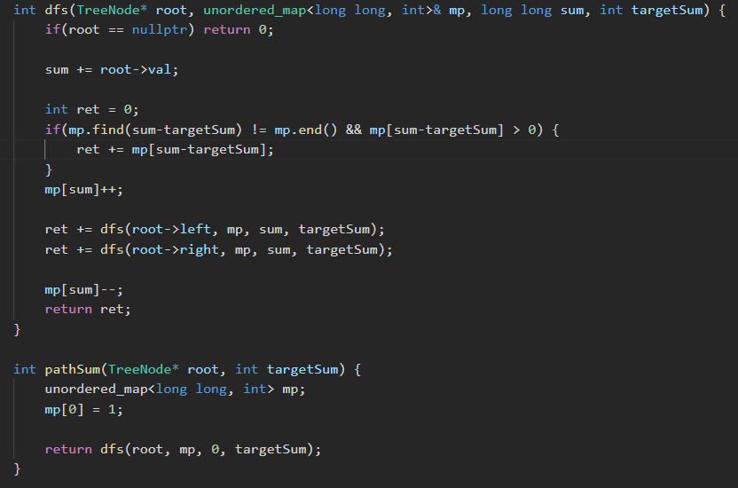

https://leetcode.com/problems/max-value-of-equation/
- Priority queue with (y-x) as value for comparison as the final calculation y2+y1+x2-x1 is linear calculation.

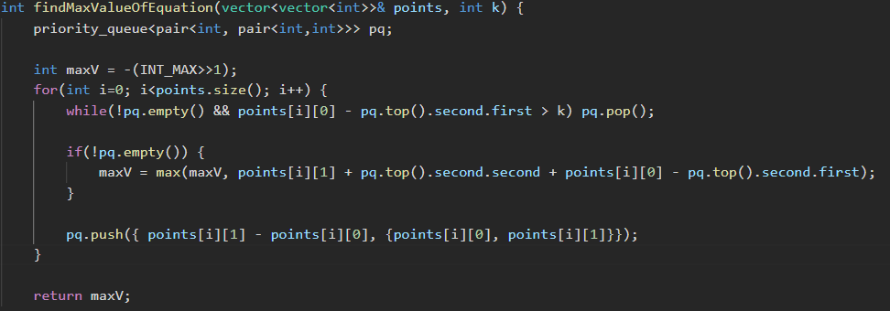

https://leetcode.com/problems/maximal-square

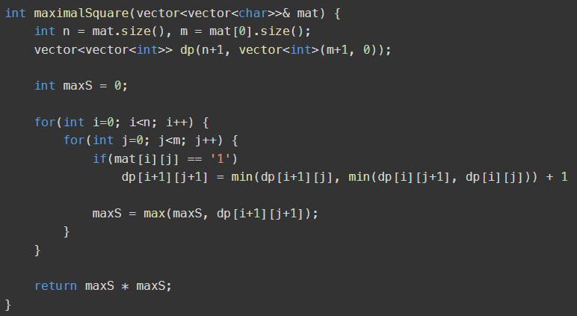

https://leetcode.com/problems/concatenated-words/description/
- Create a set for all words and then use DP for each word to find substrings which are in the word set.

https://leetcode.com/problems/minimum-insertion-steps-to-make-a-string-palindrome
- LCS modification
- https://leetcode.com/problems/minimum-insertion-steps-to-make-a-string-palindrome/description/

https://leetcode.com/problems/decode-string/
- https://leetcode.com/problems/decode-string/submissions/1668662648/

https://leetcode.com/problems/tweet-counts-per-frequency/

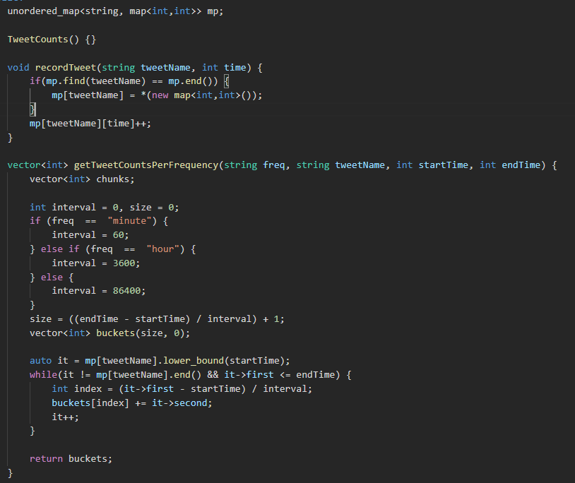

https://leetcode.com/problems/game-of-life/description/
- Do encoding for in-place changes, 1->3 and 0->2 so that %2 still gives 1 and 0.
- In the next phase change 3->0 and 2->1.

https://leetcode.com/problems/string-to-integer-atoi
- https://leetcode.com/problems/string-to-integer-atoi/submissions/346624322/

https://leetcode.com/problems/excel-sheet-column-title

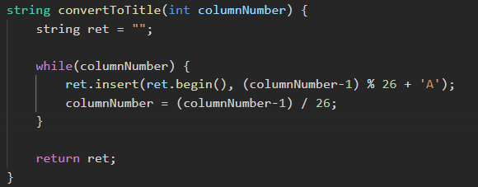

https://leetcode.com/problems/spiral-matrix/
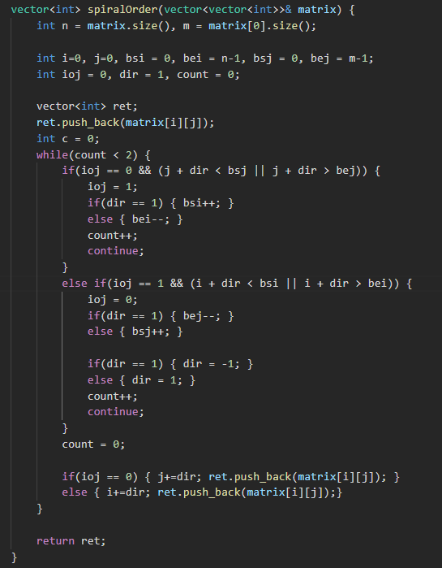

https://leetcode.com/problems/balanced-binary-tree

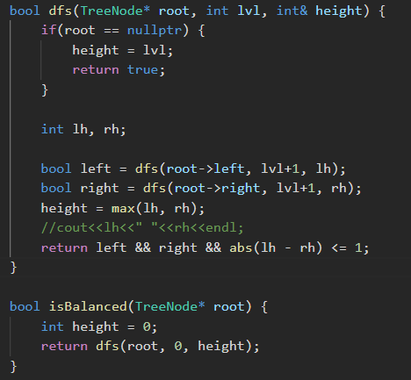

https://leetcode.com/problems/minimum-cost-to-hire-k-workers/ (Good question)
- https://leetcode.com/problems/minimum-cost-to-hire-k-workers/submissions/1676327642/

https://leetcode.com/problems/trapping-rain-water-ii/description/
- BFS using priority queue (min heap over height)
- Insert the boundary cells first
- If nextCellHeight < Height then nextCellHeight = Height and returnValue += Height - nextCellHeight
- https://leetcode.com/problems/trapping-rain-water-ii/submissions/1679275677/

https://leetcode.com/problems/combination-sum-ii/
- https://leetcode.com/problems/combination-sum-ii/submissions/1679336602/

https://leetcode.com/problems/gas-station/

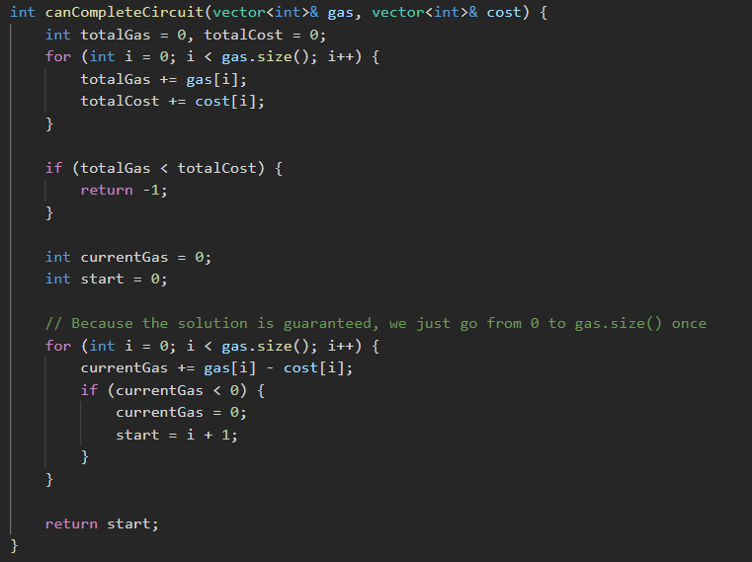

https://leetcode.com/problems/all-nodes-distance-k-in-binary-tree
- Find LCS between each pair of node then for distance between them use NodeA to Root distance + NodeB to Root distance - 2* LCS to Root distance
- Another good approach - https://leetcode.com/problems/all-nodes-distance-k-in-binary-tree/solutions/6875660/optimal-dfs-solution-frequently-asked-with-clear-explanation-dry-run-tc-sc-o-n/

https://leetcode.com/problems/snakes-and-ladders
- BFS
- https://leetcode.com/problems/snakes-and-ladders/submissions/1680410993/

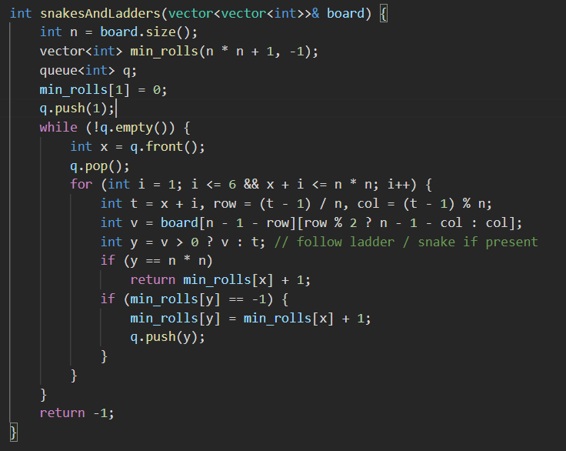

https://leetcode.com/problems/unique-binary-search-trees/
- https://leetcode.com/problems/unique-binary-search-trees/submissions/1680435497/

https://leetcode.com/problems/longest-arithmetic-subsequence/description/
- DP solution (longest increasing subsequence)
- https://leetcode.com/problems/longest-arithmetic-subsequence/submissions/1688614628/

https://leetcode.com/problems/sum-of-subarray-minimums/ (Important)
- https://leetcode.com/problems/sum-of-subarray-minimums/submissions/1689954414/
- Easy to do it two separate loops, but efficient to do it in a single loop and easy also.

https://leetcode.com/problems/valid-number/
- Just need to figure out edge cases

https://leetcode.com/problems/word-break-ii/description/
- Easy solution with unordered map for wordDict
- Trie for optimized solution
- https://leetcode.com/problems/word-break-ii/submissions/1695312862/

https://leetcode.com/problems/best-time-to-buy-and-sell-stock-iii/
- Divide the array in two parts (in two buy sell problems) and then decide on which index two separate the two buy sell

https://leetcode.com/problems/house-robber-iii/description/
- https://leetcode.com/problems/house-robber-iii/submissions/1696271546/

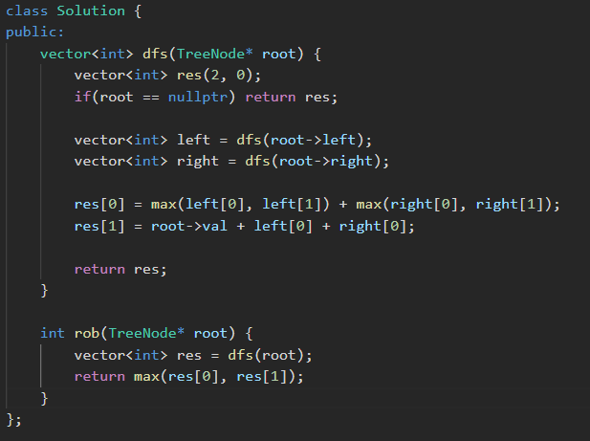

https://leetcode.com/problems/subarrays-with-k-different-integers
- https://leetcode.com/problems/subarrays-with-k-different-integers/submissions/1699197568/

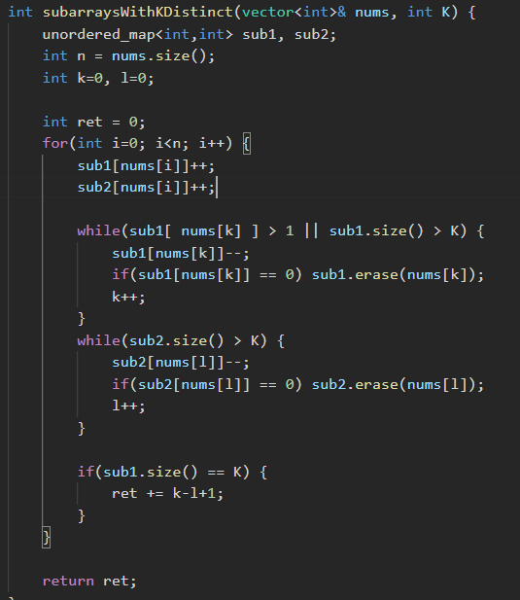

https://leetcode.com/problems/minimum-window-substring/
- https://leetcode.com/problems/minimum-window-substring/submissions/1700478614/

https://leetcode.com/problems/count-different-palindromic-subsequences (Important ques)
- https://leetcode.com/problems/count-different-palindromic-subsequences/submissions/1708878325/

https://leetcode.com/problems/number-of-operations-to-make-network-connected
- Simple DFS and connected components finding

https://leetcode.com/problems/powx-n/description/

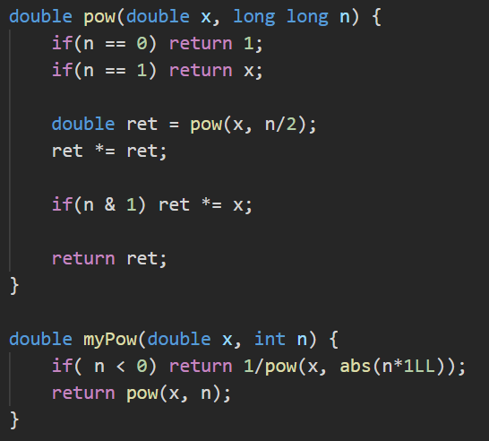

https://leetcode.com/problems/restore-the-array-from-adjacent-pairs

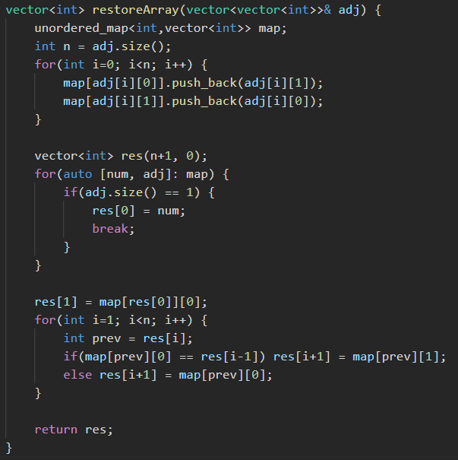

https://leetcode.com/problems/redundant-connection-ii
- https://leetcode.com/problems/redundant-connection-ii/submissions/1711837592/

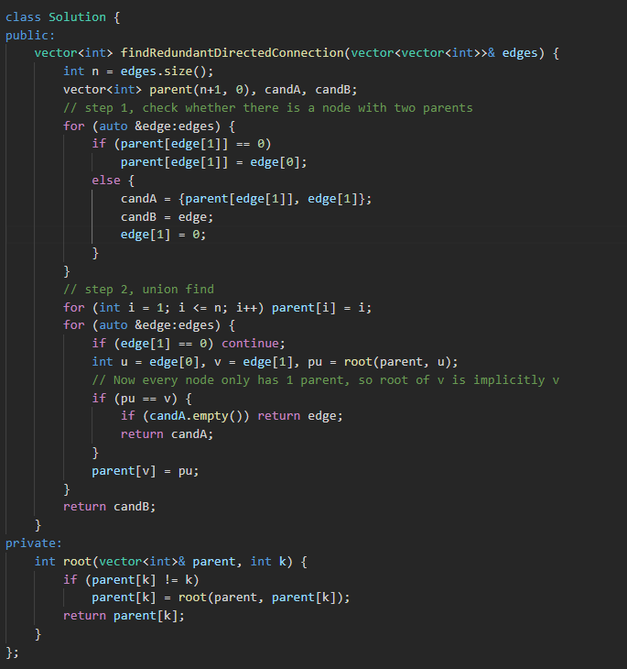

https://leetcode.com/problems/k-diff-pairs-in-an-array/
- Two pointer approach

https://leetcode.com/problems/accounts-merge/
- https://leetcode.com/problems/accounts-merge/submissions/1713059208/
- Union find on the Account Name
- Good question

https://leetcode.com/problems/rotate-image/
- Hashing of numbers
- Make all numbers positive first to make it easier

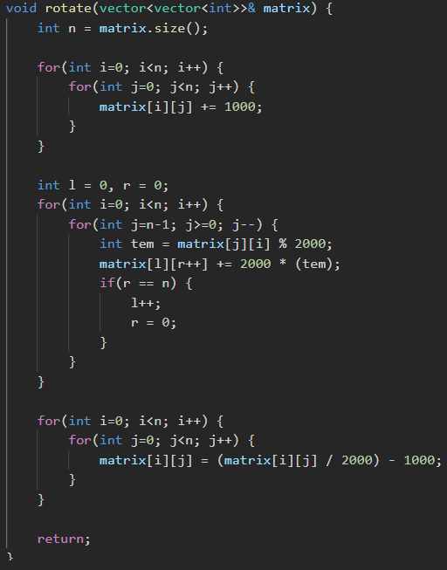

https://leetcode.com/problems/maximum-width-of-binary-tree/description/
- Use 2*level+1 and 2*level+2 for numbering of nodes and use 1e11+7 as mod to prevent overflow.

https://leetcode.com/problems/word-search/
- Simple DFS in all directions and return false mid search when word[idx] != matrix[i][j]

https://leetcode.com/problems/flatten-nested-list-iterator
- Preprocess during initialize by doing DFS

https://leetcode.com/problems/reorganize-string/
- Take one char from highest and one char from lowest frequency

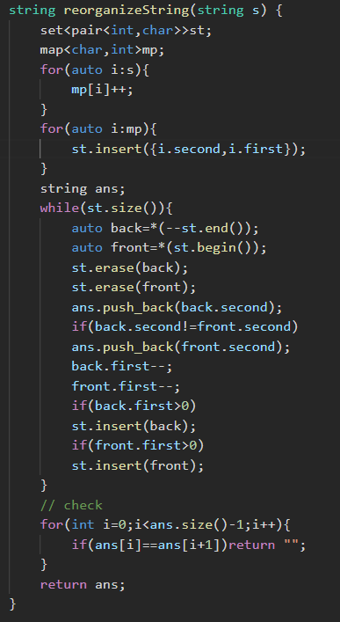
https://leetcode.com/problems/minimum-difficulty-of-a-job-schedule/description/
- DP

https://leetcode.com/problems/shortest-subarray-with-sum-at-least-k/
- Binary search of prefix sums, remove prefix sums greater than current prefix sum from the array each time as only smaller prefix sums are required for index less than current index.

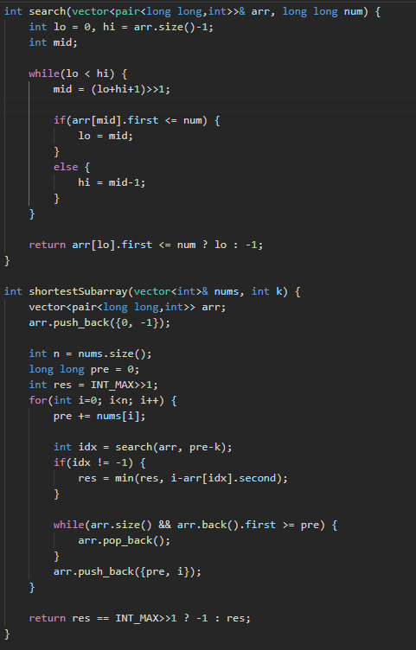

https://leetcode.com/problems/binary-tree-maximum-path-sum
- Similar to finding diameter of the tree of has edge case where child paths are negative and need to be maxed with 0.

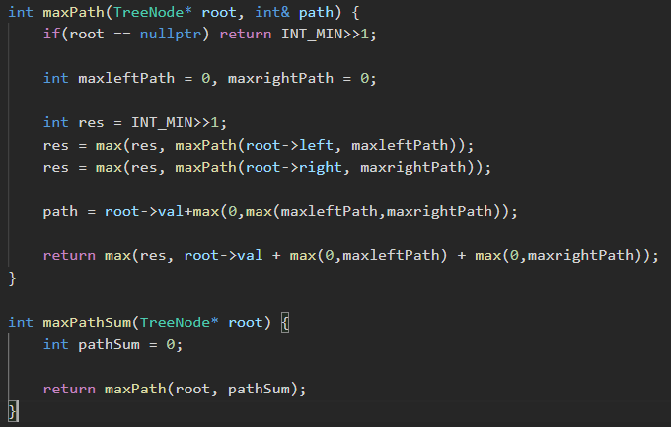

https://leetcode.com/problems/swim-in-rising-water/
- BFS with priority queue, similar to djikstra shortest path algo

https://leetcode.com/problems/sum-of-two-integers/solutions/84278/a-summary-how-to-use-bit-manipulation-to-solve-problems-easily-and-efficiently/
- Super important on BIT manipulation

https://leetcode.com/problems/redundant-connection/
- https://leetcode.com/problems/redundant-connection/submissions/1711390385/
- Add edges one by one and before adding if the two nodes in the edges are already reachable without that edge

https://leetcode.com/problems/remove-invalid-parentheses (important question)
- https://leetcode.com/problems/remove-invalid-parentheses/submissions/1736366184/
- Checks need to be done from left to right and then from right to left to fix the string

https://leetcode.com/problems/longest-substring-with-at-least-k-repeating-characters/
- Recursively split the string on characters which are less than k frequency

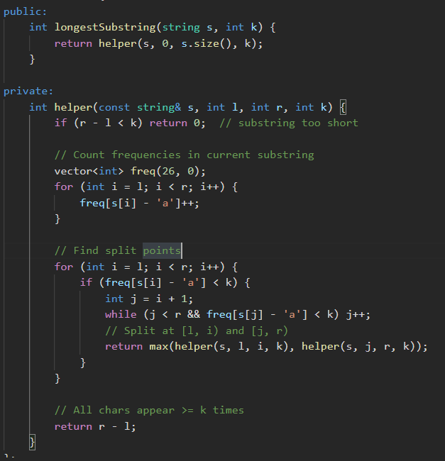

https://leetcode.com/problems/partition-to-k-equal-sum-subsets/
- BITMasking
- Use current set bitmaks to reduce need for current sum input in parameter
- This reduces parameters making it easy for DP
- https://leetcode.com/problems/partition-to-k-equal-sum-subsets/submissions/1738309803/

https://leetcode.com/problems/maximum-points-you-can-obtain-from-cards
- Sliding window approach
- Concat the same array after itself and use proper l and r pointers based on window size required.

https://leetcode.com/problems/design-hashmap
- https://leetcode.com/problems/design-hashmap/submissions/1738435332/
- Use list of nodes of size 1000
- Hashing function = key % 1000
- Loop over linked list for a key to find a key

https://leetcode.com/problems/kth-largest-element-in-an-array/
- Imp question
- Solve using quickselect

https://leetcode.com/problems/shortest-path-to-get-all-keys
- BFS with isVisited on the row and column and also the bit mask for keys

https://leetcode.com/problems/minimum-deletions-to-make-character-frequencies-unique
- Map of frequency and iterate by decreasing frequency
- https://leetcode.com/problems/minimum-deletions-to-make-character-frequencies-unique/submissions/1746510377/

https://leetcode.com/problems/kth-smallest-element-in-a-sorted-matrix
- MinHeap on the matrix

https://leetcode.com/problems/lfu-cache (Imp question)
- https://leetcode.com/problems/lfu-cache/submissions/1769183466/

https://leetcode.com/problems/merge-k-sorted-lists
- Priority queue for smallest element among all lists

